

Mehran University of Engineering & Technology

Jamshoro, Pakistan

**SOFTWARE REQUIREMENT SPECIFICATION (SRS) DOCUMENT**

**ON THE PROJECT**

**Automatic Attendance System Using Face Recognition**

**by**

**Ahsan Ali**

**B.E SWE Semester – III**

**23-BATCH**

**SECTION-III**

**Subject: Software Requirement Engineering (SRE)**

**Submitted To: Miss Mamoona Sami**



**DEPARTMENT OF SOFTWARE ENGINEERING**

**Contents**

|  |
| --- |
| **Introduction …………………………………………………………..…………………………………………………. 1**   * 1. **Purpose of SRS document ...……………….………………………………….……………………………………...……….……………………………………………….3**   2. **Intended Audience and Reading Suggestions …………………………………………………………………………………………….……………………………3**   3. **Product Scope …………………………………………………………………………………………………………………………………………………………………………3**   4. **Overview …………………………………………………………………………………………………………………….…………………………………………………….…….3**   **Overall Description ……………………………………….……….……...……………………………………………. 2**   * 1. **Product Perspective ...………………………...…………………………………………………...…………………………………………………………………………. 4**   2. **Product Functions …………………………………………………………………………………………….…..…………………………………………………………….. 4**   3. **User classes and Characteristics …………………………………………………………………………………………...……………………………………………… 4**   4. **Operating Environment ………………………………………………….…………………………………………………………………….….…………………………… 4**   5. **Design and Implementation Constraints …………………………………………………………………………………………………………………...………… 4**   6. **Assumptions and Dependencies ………………………………………………….………………………………………………………………………………………. 4**   7. **General constraints ……………………………………………………………………………………………………………………………………………………………….5**   **External Interface Requirements …………………………...……….…………………………………………... 3**  **3.1 User Interfaces ……………...………………………...………………………………………………………………………………………………………………………….... 5**  **3.2 Hardware Interfaces ………………………………………………………………………………………………………………………………………...………………….... 5**  **3.3 Software Interfaces ………………………………………………………………………………………………………………………………………………………...……… 5**  **3.4 Communication Interfaces ……………………………………………………………………………………………………………………………………………………… 6**  **Functional Requirements ………………….………………………………………………………….……………. 4**  **4.1 User Registration and Database Management ……………...………………………………...………….………….…………………………………………… 6**  **4.2 Activation of device by the teacher ……………………………………………………………….…………...…………………...…………………………………... 6**  **4.3 Teacher confirmation of Attendance …………………………………………………………….…………………………….….………………………………….…. 7**  **4.4 Attendance Records updates & Notifications for the students …………………………………………………….….…………….…………...………. 7**  **4.5 Attendance records checking for students ……………………………………………….………………………………....…………………………………….… 7**  **4.6 Report of Attendance Issue ………………………………………………………………………………….…………………….…...…………………………………… 8**  **4.7 Admin access to the attendance records and error rectification ………………………………………….…………....………………………………… 8**  **Non-Functional Requirements ……………...………………………………………………………….…………. 5**  **5.1 Usability ………………………………………………….………………………………………………………………………………………………...…………………………… 8**  **5.2 Performance ………………………………………….…………………………………………………………………………………………………...…………………………. 8**  **5.3 Reliability and Availability …………………….……………………………………………………………………………………………………...………………………… 8**  **5.4 Security …………………………………………….…………………………………………………………………………………………………………...………………………. 9**  **5.5 Portability ………………………………….…………………………………………………………………………………………………………………...……………………… 9**  **5.6 Maintainability …………………….……………………………………………………………………………………………………………………………………….………… 9**  **Aims and Objectives …..……………………………………………………………………….…………….…….…. 6**  **6.1 Aim of this Project …….…………………………………………………………………………………………………………………………………………………………… 9**  **6.2 Objectives of project .…………………………………………………………………….……………………………………………………………………………………... 9**  **Preliminary Schedule .…………………………………………………………………………………………………………………….…. 7**  **Preliminary Budget .…………………………………………………………………………………………...………………………….…. 8**  **Appendix A: Glossary .………………………………………………………………………...........................................……... 9**  **Appendix B: Analysis Models ..…………………………………………………………………………………………………………… 10**  **10.1 Use case Diagram …………………………………………………………………………………………………………………………………………………………...... 12**  **10.2 Sequence Diagram ……………………………………………………………………………………………………………………………………………………………. 13**  **10.3 Class Diagram ……………….…………………………………………………………………………………………………………………………………………………… 14**  **10.4 Dataflow Diagram ……………………………………………………………………………………………………………………………………………………….……... 15**  **Appendix C: To Be Determined List …………………………………………………………………………………….…………... 11**  **Reference ……………………………………………………………………………………………………………………….…………...…. 12** |

# **Introduction**

Many educational institutions are still using manual systems for the attendance process like calling roll no, using sheets which always results in inaccurate attendance records and consumes valuable time. This application intends to eliminate these challenges by providing face recognition technology to automate the attendance process. By doing so, it will significantly reduce the time, increase the chances of accuracy, and provide real-time access to attendance records.

* 1. **Purpose of Document**

The purpose of this Software Requirement Specification (SRS) document is to make an outline of all the requirements for the development of this project titled “Automatic Attendance System using Face Recognition”. It covers all the functional Requirements and complete implementation of the system.

In addition, this project aims to automate the traditional attendance system where the attendance is marked manually.

* 1. **Intended Audience and Reading Suggestions**

The document is planned for multiple stakeholders who are involved in the departments of development, deployment, testing and maintenance of the Automatic Attendance System. The main audience are developers, software architects, project managers, documentation writers and testers. And other stakeholders like administrative staff, teachers, and end-users or customers may also find sections of this document helpful for understanding the core functionality of the system.

* 1. **Product Scope**

This document specifies the marking of attendance for educational purposes. The objectives are to automate the manual system, avoid fake attendance, optimization of time. The scope of this project is within the educational environment whose aim is to mark the attendance for the students on a daily basis automatically.

* 1. **Overview**

There are many sections in this document that summarize this project in a clear and understandable way, including information about the system, it’s users, the hardware, and what data and functionalities are required for it.

In the second section of this complete document, the general description about the project is discussed.

The third section explains the requirements related to the interfaces such as (User, Hardware, Software, Communication).

In the end, fourth section summarizes the Functional and Non-Functional requirements involved in designing of the Automatic Attendance System.

# **Overall Description**

* 1. **Product Perspective**

The goal of this Software Requirement Specification (SRS) document is to provide an efficient way to mark students attendance digitally by replacing the manual processes. This system can be integrated with the existing system, but it operates independently due to it’s internal core working. Initially, the system will be setup in the classrooms the student faces which are already stored in the university records/database acts as a server. The teacher will activate the system by using the application at any instance during the lecture. The system will then start extract features from the student faces present in the class. The faces are continuously detected and matched from the database using AI mode within the system, those matched faces are then stored in temporary file which acts a temporary storage for storing the presented students faces. The main advantage of this system is that it continuously detects the faces throughout the entire session, rather than just during the entrance to the classroom. This helps in determining whether a particular student was present throughout the entire session or not.

* 1. **Product Functions**

Main functions of the product are:

1. Identify student face and mark attendance correctly.
2. Managing the databases like temporary files during the entire session.
3. Reports to the administration if any flaw or error occurred during the face detection.
4. Notify the detected faces to the teachers.
5. Provide accurate results to the administration, teachers, and students.
   1. **User characteristics and classes**

In this system, three types of users classes and their characteristics are involved:

1. **Administration:**

* They are responsible for system configuration, user management and maintenance of the overall system.
* Registering Students details.
* Registering Teachers details.
* Maintaining database.

1. **Teachers**

* They actually use the system to start the attendance process for their respective classes.
* Activate the system by using provided application.
* Review and finalize the attendance process.
* Adjust the attendance process (removing, modifying) students.

1. **Students**

* They also use the system to view their attendance records by means of provided application.
* Reports any technical issue related to the attendance.
  1. **Operating Environment**

The operating environment for the attendance system can be the classrooms in which the devices are implemented to detect the students faces. User application through which user (teacher, student) can access the system in different platforms like (Windows, Android, IOS). A central database system which contains the overall details related to the system users (Teachers, Students).

* 1. **Design and implementation constraints:**

The constraints such as design and implementation for automatic attendance system are the limitations define how the system needs to be created. The system must follow the Management Information System (MIS) and Administrations rules, and make sure that the system work properly in different modes of lighting e.g (sunny or dark classrooms)

* 1. **Assumptions and Dependencies:**

The assumptions and dependencies for the automatic attendance system are that we assume that the system should generate accurate results without any flaw or error. The system should open the AI mode to recognize the student faces and match them with the database. Additionally, teacher will activates the system accurately for a particular classroom.

* 1. **General constraints:**
* The device must follow backup systems like (Battery, Generator, solar systems) to remain consistent during electricity shortage.
* The device must have stable and reliable internet connectivity to communicate with database and send notification to the corresponding users of the systems like teachers and students.
* The system supports only single activation which means that at a time teacher can only activate the device just for one Section.
* Teacher can activate the device only in a specific time frame which can be before the class and also during the first 30 mins of the class.

1. **External Interface Requirements**
   1. **User Interfaces:**

The user interface for the automatic attendance system refers to the fact that the GUI of the software application should be intuitive and provides ease to users in its usage. The graphical user interface (GUI) should be easier to understand for both the teachers and students. Everything should be clear and understandable to the end-users such as real time notifications, attendance reports visibility, messages notifications.

* 1. **Hardwar Interface:**

Hardware Interface for an automatic attendance system describes the need of the physical devices that are the part of the system to provide its overall functionality that involves:

* Face Detection Devices:

Face detection devices with high precision of face detection should be required for classrooms, labs and other various lecture halls.

* Camera Types:

HD (High-Definition) face detection cameras with night vision for low-light conditions having 1080p or more resolution with a view to capture the images of multiple students at the angle of 120° present in the classrooms.

* Wi-Fi Connection:

Medium speed range wi-fi connection required to provide the data to the server site.

* Storage Devices:

Faster storage devices like SSDs having 1TB memory are required to store the detected faces.

* Mobile Devices/Laptops:

The other devices such as mobile phones and laptops must be required for the teacher to activate the system through the provided application via an operating system such as windows for laptops, Android/IOS for mobile phones.

* Power supply

The devices need a specific power supply to operate efficiently for the detection process. Backups such as UPS, Generators or solar based system are required for continuous process of face detection.

* 1. **Software Interface:**

Software interface for an automatic attendance system shows the interaction of system with other software’s which involve:

* Face Recognition API:

The system uses an specific AI-powered face recognition API such as OpenCV, for student face recognition process and matching results with the corresponding database.

* Database Servers:

A database system like MySQL, Oracle, MS Access, are mandatory to store all the records of teachers and students including (ID’s, Rolls, and face images).

* The other software system to which the system must be compatible to provide it’s view such as windows 8 and it’s above versions, Android and IOS system.
* The system needs to be interacted with high level authorization system such as Management Information System to allow the users to access the necessary information related to their specific needs.
  1. **Communication Interfaces:**

The system uses Hyper Text Transfer Protocols (HTTP) for secure communication with the server site to compare the captured images with the database. Additionally, the system will interact with eh provided application to provide accurate updates and notifications by using HTTP protocols for secure communication with central server.

1. **Functional Requirements:**

Functional requirements define the overall functionality of the system they defines what the system should do and what tasks it should perform. The list below shows all the functional requirements of this project.

**4.1** **User Registration and Database Management:**

|  |  |
| --- | --- |
| Identifier | FR-1 |
| Title | User Registration and Database Management |
| Requirement | The system shall allow the admin to register the students, teachers and other university staff members in database, and it also allows the admin to manage the database. |
| Rationale | This requirement acts as a foundation for the overall system working because all further processes depend on the accurate database information. |
| Priority | High |

**4.2 Activation of device by the teacher:**

|  |  |
| --- | --- |
| Identifier | FR-2 |
| Title | Activation of the device by the teacher |
| Requirement | The system shall support the login functionality for teachers through which they can activate the device for a particular class by providing the necessary details such as (Section, Batch, Department, Class Room#). |
| Rationale | This requirement is central to the system because it confirms that the system can only detect the relevant faces of the students related to that particular class which improves accuracy. |
| Priority | High |

**4.3 Teacher confirmation of Attendance:**

|  |  |
| --- | --- |
| Identifier | FR-3 |
| Title | Teacher confirmation of Attendance |
| Requirement | The system shall send the confirmation message to the teachers before the end of the class, which allows them to modify the attendance according to their preferences. |
| Rationale | This requirement is also central to the system that gives the overall control to the teacher to finalize or modify the student attendance before submission. |
| Priority | High |

**4.4 Attendance Records updates & Notification for the Student:**

|  |  |
| --- | --- |
| Identifier | FR-4 |
| Title | Attendance Records updates & Notification for the Student |
| Requirement | The system shall mark the attendance and update the records in the database after the confirmation of attendance from the teacher. Additionally, it should also send notifications to the students after each class to confirm that their attendance has been marked successfully. |
| Rationale | This ensures that the students are informed for their attendance and the records are updated in the database. |
| Priority | High |

**4.5 Attendance Records checking for the students:**

|  |  |
| --- | --- |
| Identifier | FR-5 |
| Title | Attendance Records checking for the students |
| Requirement | The system shall provide a feature through which students can check their attendance properly by providing their necessary details like (Roll#, Section, Batch, Department). |
| Rationale | This feature provides a way to the students to check their attendance. |
| Priority | High |

**4.6 Report of Attendance Issue:**

|  |  |
| --- | --- |
| Identifier | FR-6 |
| Title | Report of Attendance Issue |
| Requirement | The system shall provide a feature to the students to report any technical issue done by the device which can be further rectified by the admin. |
| Rationale | This feature ensures that the system is working properly in maintaining the student’s records. |
| Priority | Medium |

**4.7 Admin Access to the Attendance Records and Error Rectification:**

|  |  |
| --- | --- |
| Identifier | FR-7 |
| Title | Admin Access to the Attendance Records and Error Rectification |
| Requirement | The system should provide a full access to the administrations to access the attendance records, rectify any issue report by the students. |
| Rationale | This feature allows the admin to have access to the system for any error occurred in the system. |
| Priority | Medium |

1. **Non-Functional Requirements:**

Non-Functional Requirements define the overall qualities of the system in terms of it’s performance, usability, reliability, availability, maintainability, portability, security, scalability rather than specific functionality of the system. Some of the Non-functional requirements for automatic attendance system are listed below:

* 1. **Usability**

The GUI of the system must be user friendly and provide ease to the user in it’s usage. Additionally, the users

can easily perform their tasks with minimal effort like students should be able to check their attendance with

just a few clicks. And also, it allows the teachers to activate the device, review and mark the attendance

within 2 minutes.

* 1. **Performance**

The system shall process quickly, and match students’ faces with the database just within the 20-seconds of detection. The system shall also handle the large number of students at a time without losing it’s performance. Additionally, The system shall also support smooth attendance marking if multiple classes are being conducted at the same time across the whole campus.

* 1. **Reliability and Availability**

The system must provide 100% availability during the operational hours (6 AM – 11 PM) and provide continuous access to the system for all the users. Additionally, the system must be reliable so that it should be able to handle the different student facial expressions (Happy, Sad, Angry) or any other mood with 99% rate of accuracy to facilitate the reliable attendance marking.

* 1. **Security**

All the transmission of data between the device and application must be secure. Additionally, the system should store the student faces in a secure temporary file which can be matched with the database. Furthermore, the system should comply with the GDPR for managing the student’s personal data to ensure secure storage and processing of student’s information.

* 1. **Portability**

The portability for the automatic attendance system can be viewed in a way that the system can easily be used in different platforms like Windows, Android and IOS without requiring any changes in the system.

* 1. **Maintainability**

The system should be designed in such a way that allows easy modifications and management of individual components like (camera, databases). Comprehensive and detailed documentation must be provided which facilitates efficient updates and enhancements in the system. Additionally, the system must support modular updates which ensure that the specific component can be updated and replaced without affecting the overall functionality of the system.

1. **Aim and Objectives**
   1. **Aim of Project**

The aim of this project is to automate and improve the accuracy in the student attendance process within the boundary of the university by using facial recognition technology.

* 1. **Objectives of Project**
     1. **Remove the manual attendance process:**

The objective of the system is to completely remove the manual attendance process, increase efficiency, and reduce teacher’s workload.

* + 1. **Provide Accuracy in Attendance process:**

To provide accurate results in the attendance process by using AI-based facial recognition technology, and to reduce the chances of errors which can occur in the manual processes.

* + 1. **Provide Real- Time Access:**

To provide real-time updates and notifications for both students and teachers.

* + 1. **Facilitate Attendance Management:**

To provide the teacher a tool to manage the attendance records efficiently, like ability to finalize the

attendance records, update and review them effectively.

* + 1. **Generate Accurate Attendance Records:**

To automatically generate accurate records of attendance for all the users of the system like (Admin, Teacher Student).

# **Preliminary Schedule**

|  |  |  |  |  |  |
| --- | --- | --- | --- | --- | --- |
| S.no | Process | Participants | Starting Date | Ending Date | Time Period |
| 1. | **Requirement Elicitation** | **User, Stakeholders, Record keeper** | **01-10-2024** | **08-10-2024** | **1 week** |
| 2. | **Requirement Analysis** | **Analysts, Developers** | **08-10-2024** | **10-10-2024** | **2 Days** |
| 3. | **Requirement Documentation** | **Analysts** | **10-10-2024** | **14-10-2024** | **4 Days** |
| 4. | **Requirement Review** | **Users, Stakeholders** | **14-10-2024** | **15-10-2024** | **1 Day** |
| 5. | **Prototyping** | **UI/UX Designers, Developers** | **15-10-2024** | **23-10-2024** | **1 week** |
| 6. | **User Feedback** | **Users, Stakeholders** | **23-10-2024** | **25-10-2024** | **2 Days** |
| 7. | **Implementation** | **Developers** | **25-10-2024** | **10-12-2024** | **1.5 Month** |
| 8. | **Testing & Debugging** | **Quality Assurance Team, Testers** | **10-12-2024** | **20-12-2024** | **10 Days** |
| 9. | **Deployment** | **Developer** | **20-12-2024** | **27-12-2024** | **1 week** |
| 10. | **User Training** | **Training Team** | **27-12-2024** | **30-12-2024** | **3 Days** |
| 11. | **Maintenance & Support** | **Developers** | **30-12-2024** | **_** | **Ongoing** |
| Overall, 88 Days Except Maintenance | | | | | |

# 

# **Preliminary Budget**

|  |  |  |
| --- | --- | --- |
| S.no | Process | Budget |
| 1. | **Requirement Elicitation** | **15k** |
| 2. | **Requirement Analysis** | **8k** |
| 3. | **Requirement Documentation** | **12k** |
| 4. | **Requirement Review** | **5k** |
| 5. | **Prototyping** | **14k** |
| 6. | **User Feedback** | **-** |
| 7. | **Implementation** | **150k** |
| 8. | **Testing & Debugging** | **12k** |
| 9. | **Deployment** | **6k** |
| 10. | **User Training** | **8k** |
| 11. | **Maintenance & Support** | **25k** |
| 12. | **Developer Salary** | **200K** |
| 13. | **Extra Expenditure** | **80K** |
|  |  | **535K (5 Lac 35 thousand)** |

# **Appendix A: Glossary**

This glossary section will explain the fundamental terms that are used in this Software Requirement Specification (SRS) document for the Automatic Attendance System using facial recognition. It simply defines the concepts like:

* AI – Artificial Intelligence. The technology which enables the machines to enhance their performance and make decisions depending on the available information.
* Facial Recognition Algorithm: A way used by the system to identify and authenticate the student face.
* Admin: A user of the system which has full access to the system in controlling, managing the system records.
* Temporary File: A storage space where student faces shall be stored for a short period of time during the lecture.

**10. Appendix B: Analysis Models**

**10.1 Use Case Diagram**

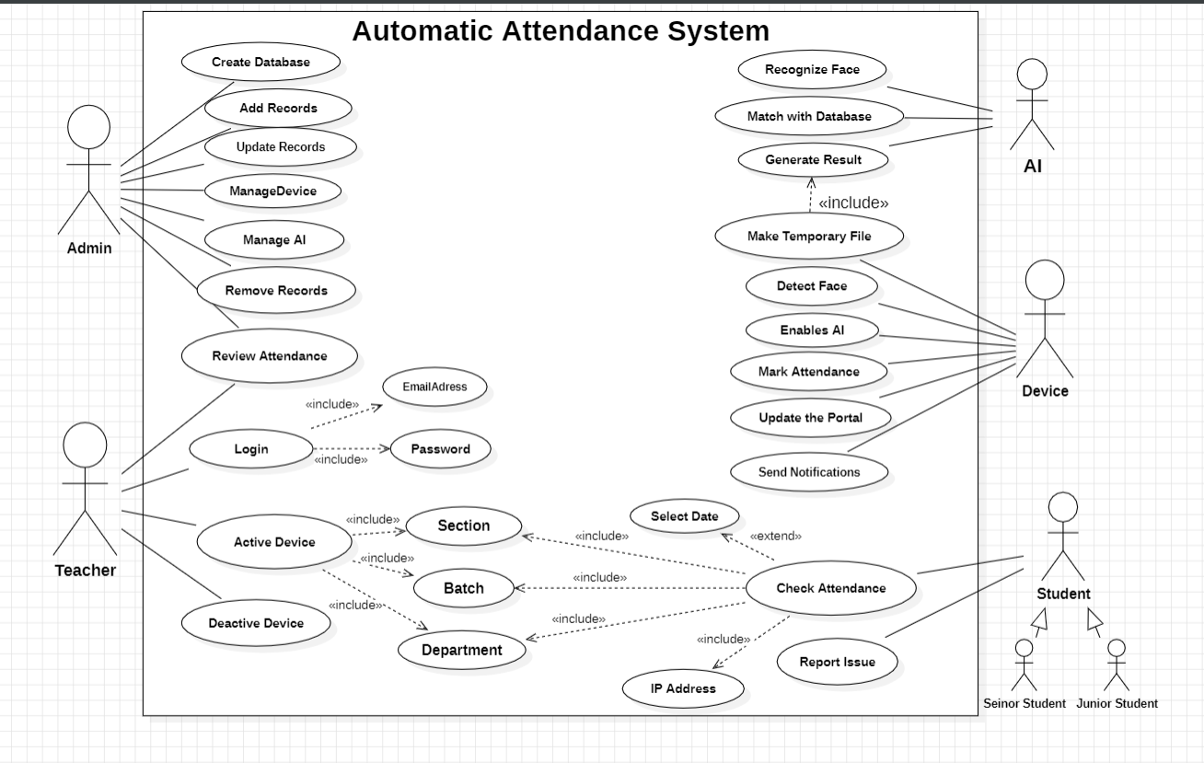

**10.2 Sequence Diagram**

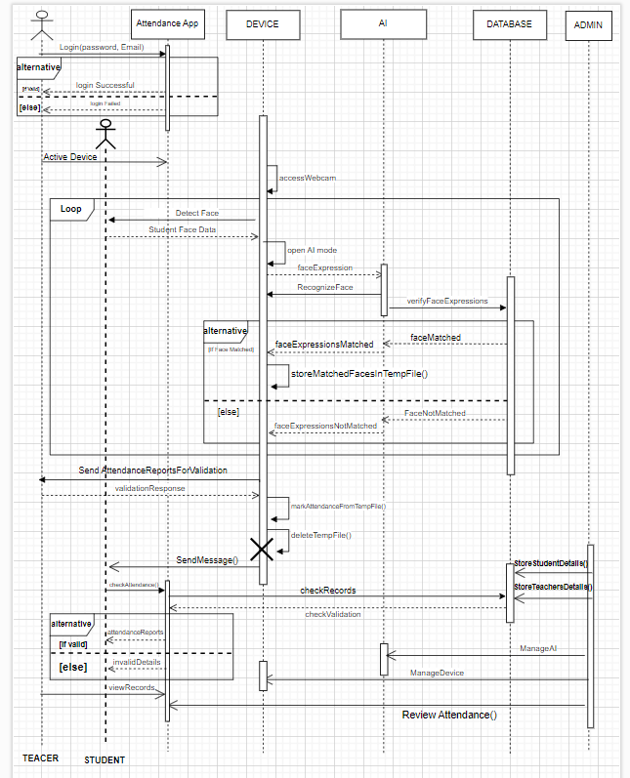

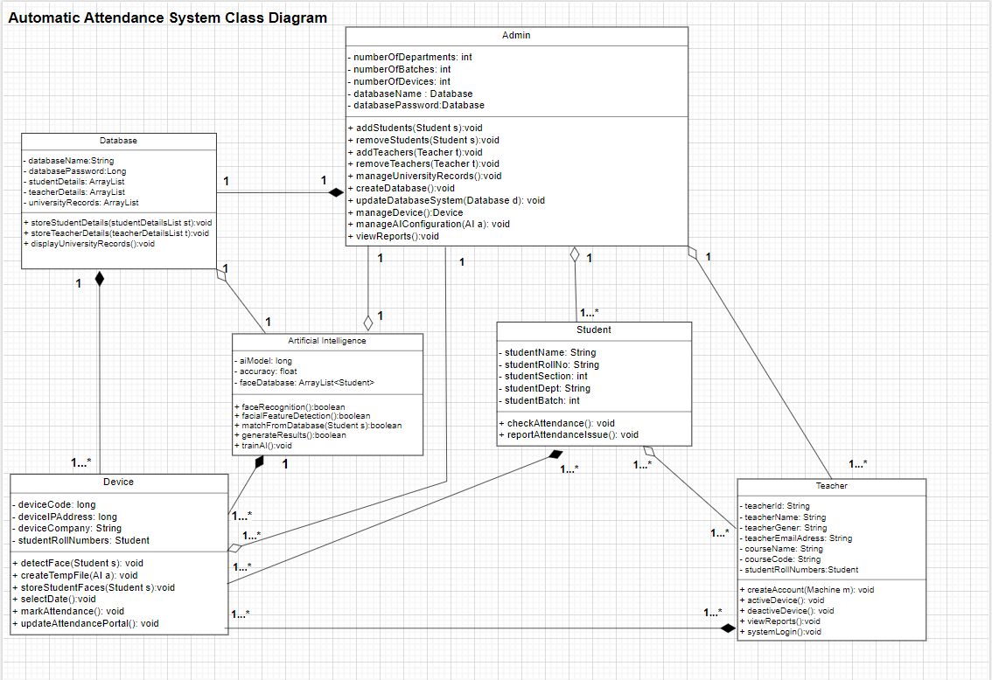**10.3 Class Diagram**

* 1. 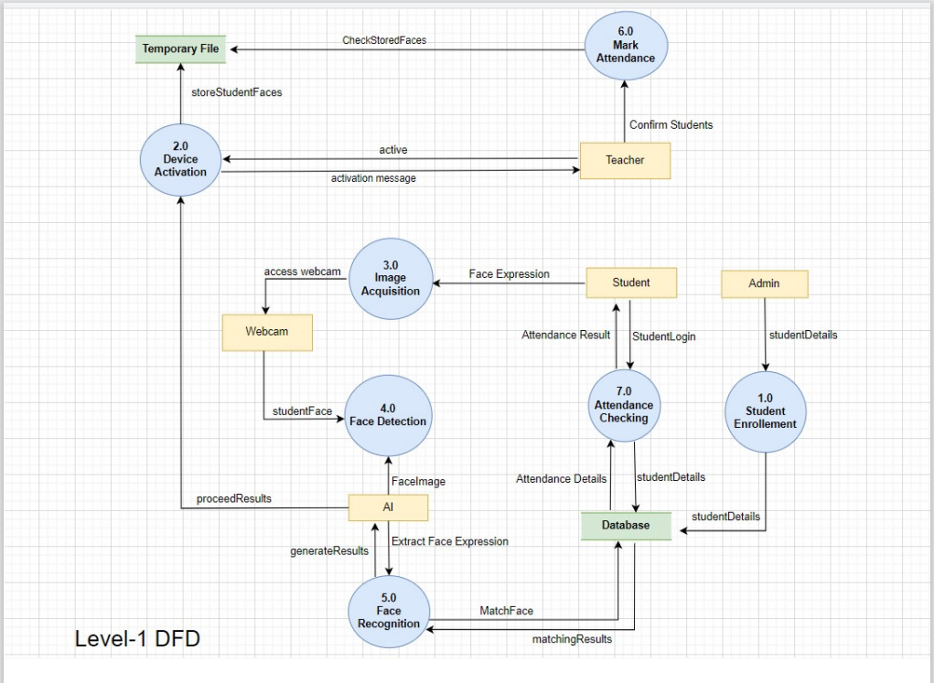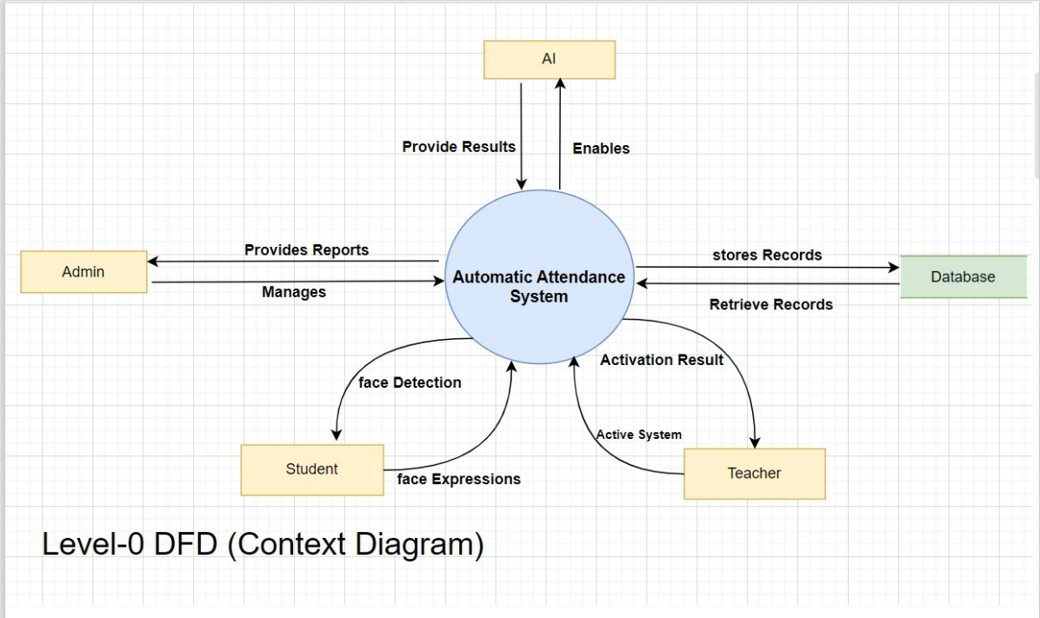**Dataflow Diagram**

1. **Appendix C: To Be Determined List**

This section contains the number of list items that are still under review or to be finalized in the Software Requirement Specification (SRS) document for the Automatic Attendance System using Facial Recognition. These points are subject to ongoing discussion and can be updated to accuracy and completeness. These are the things that require resolution within the context of the project.

**C.1 Device Specification for Classrooms**

The exact hardware specification for facial recognition devices in classrooms are need to be finalized which includes camera type, it’s resolution, processing speed.

**C.2 AI Accuracy Rate for Face Recognition**

The acceptable accuracy rate of the face recognition algorithm need to be defined. Additionally, further testing is required to establish the identification of student under different lighting and expression variations.

**C.3 Integration with MIS System:**

Integration specifics with the existing Management Information System (MIS) are to be finalized. This includes the decisions on which data will be shared between the two systems and review conditions for attendance records like (Wi-fi connectivity) also minimum requirement for attendance (75% attendance requirement).

# **References**

*This document refers to the IEEE SRS standards and related documentation on facial recognition technology.*

* [*https://ieeexplore.ieee.org/document/9641486*](https://ieeexplore.ieee.org/document/9641486)
* [*https://www.scaler.com/topics/smart-attendance-system-using-face-recognition/*](https://www.scaler.com/topics/smart-attendance-system-using-face-recognition/)
* *https://www.slideshare.net/slideshow/smart-attendance-system-using-facial-recognition/166493324*

**Plagiarism Checking**

